December 12, 2019, noon-1
Attending:
OKPTCE: Janice Howman, Amy Both, Jamie Bayliss, Kara Lee, Paula DeLorm, Allison Durham, Christine McCallum, Deb George, Karen McIntyre, Amber Boyd
Clinicians:
- Lori Baehl, Baptist Health Louisville Acute Care
- Makke Dodd, Healthcare Therapy Services
- Michele Hippler, University Hospital Cleveland
- Jessica Michel, Athletico Ohio SCCE
- Julie Gruden, Cleveland Clinic
- Paul Gagne, Novacare
- 17409364944
- 12162724242
- Zachary Hughes, HCF of Lima, OH
- Stephanie Westrick, Cleveland Clinic Children’s Hospital
- Brandy Barrett of Frazier Rehabilitation
- Diane Weiglein, St. Elizabeth Healthcare
- Sarah Fultz, Cleveland Clinic Children’s Hospital
Amy Both facilitating:
Fall Clinical Zoom meeting
- Common Terminology
  - Shared ACAPT Task force powerpoint
  - June 2019 Journal of Physical Therapy Education article referenced
  - Website highlighted
  - Janice noted that the Task Force has had the article, website, and memes used
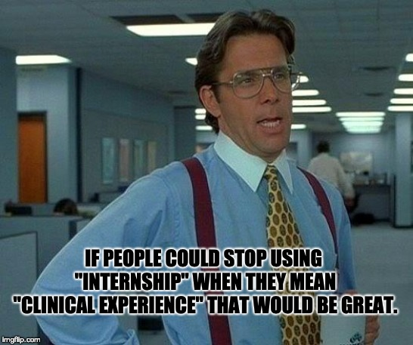
  - Paul Gagne has noticed that schools are using the new terminology. Sees other SCCEs using older terminology. He appreciates the attempts to be on the same page.
- Update on tweaks to March Mailing form -- sent between March 1-15, returns April 30th -- forms updated.
    - Several participants were enthused about the standardization of dates
    - Requests for numbers of students
    - Special requests for name of students
    - Slot release will occur as placements are complete, with final release date by Dec. 1
      - AB discussed variations among programs with timing of the curriculum, clinicals, and placement processes
      - Sarah Fultz asked about a 3-6 month window -- some AIs have a December placement process for a January clinical -- and Sarah has trouble staffing this
      - Stephanie Westrick had insights that it is difficult to place students with their optimal interest match if they cannot look at the majority of students at one time (geography)
      - SCCE at one site sends out a message to all DCEs that there is a cancellation at the site and a slot is available (JH shared this)
      - Brandy Barrett noted that she likes to get the name and email of the student, so that she can move forward and plan appropriately
  - Placement process document may inform us as to site confirmation of matches
  - We are aware of our different time frames but we want to work to provide efficiencies
  - Janice threw out the question about how sites determine how they take students for first, intermediate, and terminal full time clinicals
    - Sarah Fultz noted that they typically take terminal or next to the last
    - Lori Baehl noted that some of her clinicians really like the early students, and they are working on how to integrate these productivity demands

https://healthcareeducationtransformationpodcast.libsyn.com/ from Sean Gallivan 1/6/20 and 1/18/20 - info shared in the chat with all.

