PT CPI Training and Use- Fall 2018

CPI Training Documents PT CPI Web:
- Log onto PT CPI Web: https://cpi2.amsapps.com/
- After logging in, click on the link in the Online Help Center for New User Training (on the right side of the home page)
- Click on the APTA Physical Therapist PT CPI to view the Training Modules

Click Here

- After completing the Training Module, use this link to complete the Assessment:
APTA Learning Center Post-Test Assessment for PT CPI
- You must be able to complete the PT CPI Post-Test with a 70% or better to be able to begin a student’s assessment.

- Next follow these steps:

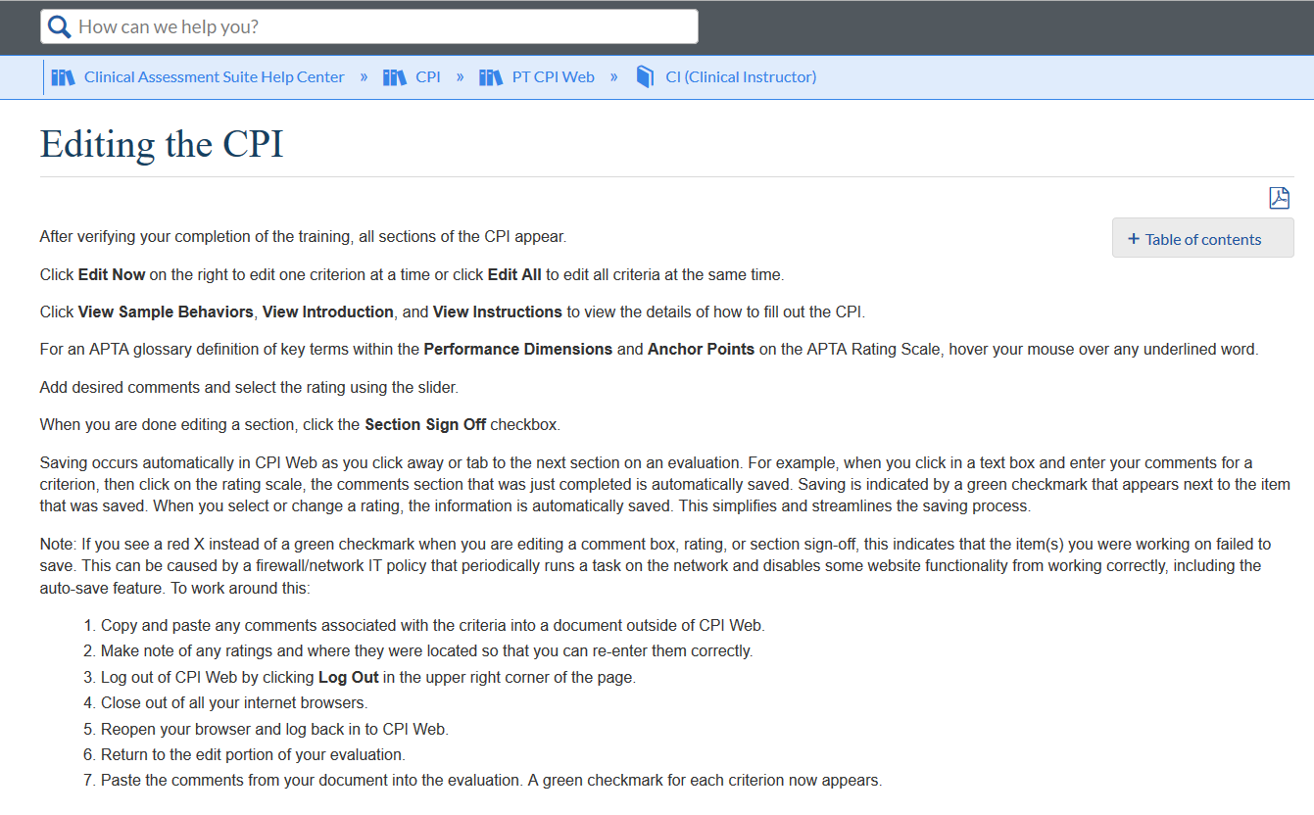

In addition to these instructions, other helpful advice includes:
SAVING PROCEDURES
Our team has restructured the way that evaluation data gets saved when filling out the CPI online. Here is how it works:
- We have removed all Save buttons from the CPI. The saving process occurs automatically as you "click" or "tab" to the next section on the evaluation. For example, when you click in the text box and enter in your comments for a criterion, when you go to click on the rating scale, the comments section that was just completed is automatically saved. When you select or change a rating, the information gets automatically saved. This simplifies and streamlines the saving process. You can navigate away from the page and then check back on your progress immediately and you will see all of your data listed and saved.

- When all sections have been completed along with the Section Sign-offs, in order to Sign Off on the evaluation, you would need to click on one of the Sign Off buttons, scroll to the bottom of the page, select the checkbox associated with the signature, and then click on the Save button. Once you sign-off, you will no longer be able to edit the CPI.

- If you have any questions, please contact the CPI Web Support Team at ptcpiwebsupport@liaisonedu.com

PT/PTA TOGGLE SWITCH TO LOCATE STUDENT’S CPI

- In order to edit the evaluation, you would need to click on the Edit link found in the Actions column in the Evaluations tab. If you don’t see the student’s name listed, the reason is because you are looking at PT CPI Web (both PT CPI Web and PTA CPI Web are accessible from the same login). There is a toggle switch that will take you to PTA CPI Web by clicking on the circle in front of PTA CPI Web in the upper right hand corner of the screen, next to where it says “Logged in as”. In order to switch back to PT CPI Web, you would click on the circle in front of PT CPI Web in the upper right hand corner of the screen, next to where it says “Logged in as”.

- If you are still having issues, please send an email to PT CPI Web Support at ptcpiwebsupport@liaisonedu.com

